

Department of Applied Mathematics and Statistics (AMS)

Internship Proposal
Student's Name : LUN Chanpoly
Company Name : Decent Actuarial Consultants (DAC)
Internship Position : Actuarial Intern
Internship Project Title : Frequency-Severity Machine Learning Models for Health Insurance Premium Pricing: A Case Study of Hospital Reimbursement in Cambodia
Internship Started Date : 16th March 2026
Internship Ended Date : 16th June 2026

About the Company
Company Profile: Decent Actuarial Consultants (DAC) is an independent actuarial consulting firm with offices in Taipei (founded 2013), Phnom Penh (2015), and Hanoi (2017). Led by CEO Dr. Chris Chih-Ching Chan (PhD, FSA, FAIRC, FCAA), DAC specializes in supporting insurance companies throughout their entire lifecycle — from pre-establishment market research and business plan development, through early-stage product design and regulatory compliance, to mature-stage risk management, financial soundness reporting, and capital management, and into transition-stage M&A advisory and valuation services. DAC also serves as the Head of Business in Taiwan and Cambodia for RNA Analytics, a global actuarial software and consulting company whose R3S Modeler is used in over 50 countries.
Company History: DAC was founded in Taipei in 2013 by Dr. Chris Chan, expanding to the Phnom Penh office in 2015 and the Hanoi office in 2017. The company's cross-border expansion follows an actuarial S-curve strategy: recognizing that Taiwan's mature insurance market (penetration exceeding 10%) offers limited growth, while Cambodia and Vietnam — both at around 1% insurance penetration with young, growing populations — represent the initial and growth phases of the S-curve with enormous potential. DAC has built strategic alliances with Japanese consulting firms (Globacs/APACS), Korean actuarial consultancies, and academic institutions. The company has been engaged by government units including USAID and GIZ, and actively participates in regional industry events such as the Vietnam Actuarial Conference.
Mission: To support insurance companies throughout their lifecycle by applying actuarial expertise and data science to emerging markets in Southeast Asia. As Dr. Chan states: 'Correctly pricing risk is creating value. The less you understand, the more easily you become afraid.' DAC is committed to bringing global actuarial modeling standards to Cambodia and Vietnam, where the talent shortage is severe — Cambodia has only 2 FSA-qualified actuaries serving nearly 40 insurance companies.
Vision: To become the leading cross-border actuarial consulting firm in Southeast Asia, cultivating local talent for local business while connecting them to global opportunities. DAC envisions a future where Cambodian students with strong math and analytics skills can build global actuarial careers, and where data-driven insurance pricing makes coverage more accessible and affordable across the region.
Products and Services: DAC provides a full spectrum of actuarial services organized around the insurance company lifecycle: (1) Pre-establishment — market research, feasibility studies, finding investors; (2) Early stage — product design, regulatory compliance setup, management training; (3) Maturity — risk management, financial soundness, product optimization, regulatory reporting, capital management; (4) Transition — M&A advisory, valuation, due diligence; (5) Transformation — integration, knowledge transfer, restructuring. Additionally, DAC leads RNA Analytics' business in Taiwan, Cambodia, and Vietnam, implementing the R3S Modeler actuarial software platform. The company also develops custom data science and ML solutions for insurance pricing, including the DAC HealthPrice platform.
Organizational Structure: DAC operates across three offices: Taipei (headquarters), Phnom Penh, and Hanoi, with teams collaborating across regions on client projects. The CEO Dr. Chris Chan oversees all offices and also serves as an Adjunct Assistant Professor at Soochow University and Feng Chia University. The Phnom Penh office handles Cambodian insurance company consulting, data analysis, model building, and pricing projects. Interns work directly on real client projects alongside senior actuaries, gaining exposure to tools including R3S Modeler, R, Excel, SQL, and Python. DAC actively cultivates local talent through partnerships with Cambodian universities and offers scholarship opportunities and paths to international training.
Project Description
Problem Statement: Cambodia faces a critical healthcare financing challenge. Out-of-pocket spending accounts for approximately 55% of total healthcare expenditure — one of the highest rates in Southeast Asia. Health insurance penetration remains below 5%, with the vast majority of the working population (estimated at 84%) lacking any form of health coverage. Current insurance pricing in Cambodia relies primarily on manual underwriting or simple factor tables that do not account for the complex interactions between risk factors such as age, smoking status, exercise habits, occupation, and pre-existing conditions. There is no publicly available, data-driven pricing tool that allows individuals or insurers to generate personalized hospital reimbursement premiums based on actuarial models. Furthermore, the absence of large historical claims datasets in Cambodia's young insurance market makes traditional actuarial table construction challenging. Machine learning approaches that can extract patterns from limited data offer a potential solution, but their effectiveness relative to classical actuarial methods in this data-scarce context has not been systematically evaluated.
Project Goal: To design, implement, and deploy DAC HealthPrice — an AI-powered, production-ready web platform that generates personalized hospital reimbursement insurance premiums using frequency-severity machine learning models. The platform will serve as both a practical pricing tool for DAC's insurance clients and an academic contribution through the systematic comparison of four ML modeling approaches for insurance pricing in Cambodia's emerging market.
Objectives:
• Develop and compare four machine learning approaches for predicting IPD hospital reimbursement claim costs: Poisson + Gradient Boosting, Poisson + Gamma GLM, Tweedie regression, and Neural Network (MLP).
• Build a full-stack web platform with a guided step-by-step wizard interface that captures 7 user risk factors (age, gender, smoking, exercise, occupation, region, pre-existing conditions) and generates personalized premiums.
• Implement an AI-powered chatbot advisor (using Claude API) that recommends optimal insurance plans, explains pricing factors, and suggests cost optimizations based on the user's risk profile.
• Deploy the platform on cloud infrastructure (Vercel, Render, Supabase) with an administrative dashboard for claims data upload, model retraining with champion-challenger validation, and user behavior analytics.
• Conduct rigorous model evaluation using 5-fold cross-validation and held-out test sets, plus pricing sensitivity analysis across key risk factors.
• Support IPD hospital reimbursement as the core product with four tier options (Bronze, Silver, Gold, Platinum) and three optional rider add-ons (OPD, Dental, Maternity).
Benefits:
• For DAC: A deployable pricing engine that can be white-labeled for insurance company clients, demonstrating the company's actuarial technology capabilities.
• For the insurance industry: The first data-driven, ML-powered hospital reimbursement pricing tool designed specifically for Cambodia's market, enabling more accurate and transparent premium calculations.
• For policyholders: A transparent pricing experience where users can see exactly how their risk factors affect their premium, with AI-assisted plan recommendations that help them choose optimal coverage.
• For academia: A systematic comparison of classical actuarial GLMs versus modern ML approaches in a data-scarce emerging market, contributing evidence to the ongoing debate about model complexity versus interpretability in insurance pricing.
Methodology/Activities
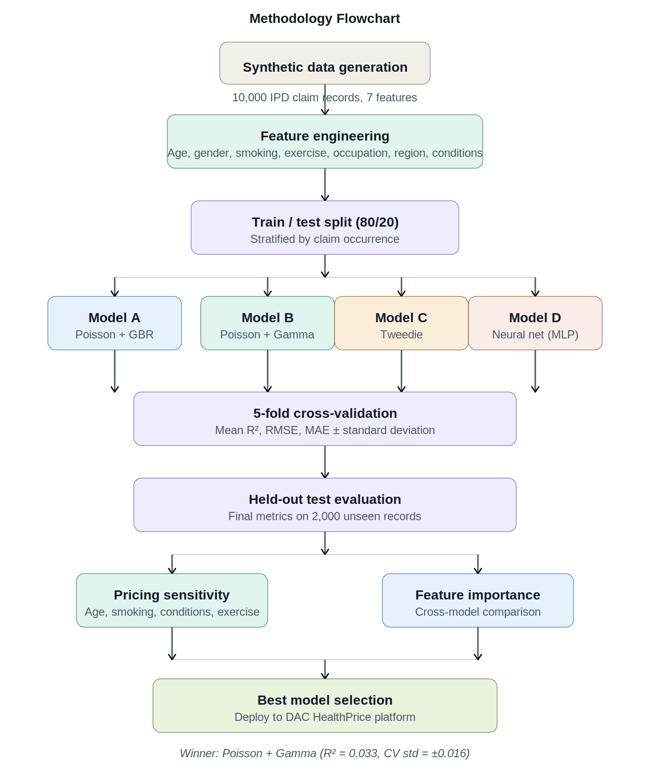
Figure 1: Methodology flowchart — DAC HealthPrice model comparison framework
Data Collection:
The project generates a synthetic dataset of 10,000 IPD hospital reimbursement claim records with realistic distributions based on Cambodian demographics and healthcare cost patterns. The synthetic data generation process models claim frequency using Poisson distributions with base rate 0.12 claims per year, modified by multiplicative risk factors for age (+0.8% per year above 35), smoking status (1.0x to 1.40x), exercise level (0.80x to 1.20x), occupation type (0.85x to 1.30x), and pre-existing conditions (+20% per condition). Claim severity follows a Gamma distribution with a base mean of $2,500 per claim, adjusted by age, region, smoking, and occupation factors. The resulting dataset has a 16.1% claim rate with mean severity of $3,517 per claim — consistent with hospital reimbursement patterns in emerging Southeast Asian markets.
Data preprocessing includes feature encoding (categorical to numerical), input validation and sanitization, and stratified train-test splitting (80/20) to ensure proportional representation of claimants and non-claimants in both sets.
Data Analysis:
Statistical analysis is performed using Python with scikit-learn, NumPy, and Pandas. Exploratory data analysis examines the distribution of claim frequency and severity across risk factor categories, identifies correlations between features, and validates the synthetic data generation process. Descriptive statistics include claim rate by demographic group, severity distribution analysis, and zero-inflation quantification (83.9% of records have zero claims).
The analysis uses R-squared, RMSE (Root Mean Squared Error), and MAE (Mean Absolute Error) as evaluation metrics. Cross-validation standard deviation measures model stability across different data subsets.
Model Development:
Four modeling approaches are developed, trained, and validated:
• Model A — Poisson + GradientBoosting: Poisson regression for frequency (claim count prediction) combined with GradientBoostingRegressor (150 estimators, max depth 4, learning rate 0.07) for severity. This is the production model deployed in the platform.
• Model B — Poisson + Gamma GLM: Same Poisson frequency model paired with a Gamma generalized linear model for severity. This is the classical actuarial approach used as the academic benchmark.
• Model C — Tweedie regression: A single model using the Tweedie distribution (power=1.5) that predicts total annual cost directly without decomposition into frequency and severity components.
• Model D — Neural Network (MLP): Multi-layer perceptron with two hidden layers (64, 32 neurons), ReLU activation, early stopping, and StandardScaler input normalization. Separate networks for frequency and severity.
All models are evaluated using identical 5-fold cross-validation on the training set (8,000 records) followed by final evaluation on the held-out test set (2,000 records). Champion-challenger validation is implemented for production model updates.
Data Visualization:
Results are visualized through multiple channels. The web platform itself serves as an interactive visualization — users see their premium broken down into frequency, severity, tier factor, and loading components. Model comparison results are presented in formal tables and charts for the thesis, including line charts for age sensitivity, bar charts for smoking and pre-existing condition sensitivity, and feature importance comparison tables across all four models.
The administrative dashboard visualizes user behavior data through summary metric cards (total quotes, average age, rider adoption rates), tier distribution charts, and smoking status distribution displays.
Stakeholder Engagement:
The project involves regular progress updates with the DAC supervisory team, incorporating their feedback on actuarial methodology, product structure, and user interface design. Key decisions made through stakeholder input include: focusing on IPD hospital reimbursement as the core product (rather than OPD), removing Vietnam from the initial market scope to focus exclusively on Cambodia, quantifying exercise input through days per week and minutes per session (rather than categorical labels), adding 'Retired' as an occupation category, and implementing dynamic AI tier recommendations labeled as 'AI recommended' on the plan selection interface.
Implementation:
The platform is deployed as a three-tier architecture: React frontend on Vercel (step-by-step wizard with navy/gold design), FastAPI backend on Render (Python with 8 embedded ML models), and PostgreSQL database on Supabase (4 tables: quote log, user behavior, claims, model registry). The frontend communicates with the backend via REST API with CORS configuration. Administrative functions are protected by API key authentication with rate limiting at 30 requests per minute.
Key implementation challenges include Render free-tier cold starts (30-second delay after inactivity), CORS configuration between Vercel and Render domains, Supabase connection pooling (must use pooler URL on port 6543), and ensuring the AI chatbot has full pricing context for meaningful recommendations.
Innovative Techniques:
• AI-powered plan advisor: An integrated Claude API chatbot that receives the user's full risk profile and pricing result as context, enabling personalized plan recommendations, pricing explanations, and cost optimization suggestions in natural language.
• Dynamic AI tier recommendation: The system automatically identifies the optimal IPD tier based on the user's risk factors and labels it 'AI recommended' on the plan selection interface, adjusting in real-time as inputs change.
• Champion-challenger model governance: When new claims data is uploaded, a challenger model is trained and compared against the champion. The challenger is only promoted to production if its R-squared meets or exceeds the champion minus a 2% tolerance threshold.
• Quantified exercise input: Instead of categorical labels (Sedentary/Light/Moderate/Active), users input days per week and minutes per session using interactive sliders. The system auto-derives the activity level and displays a color-coded badge showing total weekly minutes.
• Dual data stream architecture: User quote data (behavioral analytics) and historical claims data (model training) are stored in separate tables with distinct purposes, preventing contamination of training data with unvalidated user inputs.
Evaluation and Testing:
Model evaluation follows a rigorous academic protocol. All four models are trained on identical 80% training data and evaluated on the same 20% held-out test set. Five-fold cross-validation on the training set provides mean and standard deviation for R-squared and RMSE, measuring both accuracy and stability. Pricing sensitivity analysis tests how each model's predictions change across individual risk factors (age 20-70, smoking Never/Former/Current, 0-3 pre-existing conditions, exercise Sedentary to Active) while holding other factors constant.
Platform testing covers API endpoint validation, CORS configuration, database connectivity, model loading verification (8 models at startup), input validation and sanitization, rate limiting, admin authentication, and fallback local pricing when the backend is unavailable. The system was evaluated through a QA audit scoring 7.5/10, with 14 of 17 identified issues resolved in the v2.1 security update.
Seen and Approved by Advisor

_________________________________
Approved by Supervisor

________________________________

